***HOTSTAR CLONE USING HTML, CSS, AND JS***

122010301052 – UMA SHAKAR

122013016023 – SAI KUMAR

122010330028 – MANOJ KUMAR

122010331035 - RAHUL

**Description**

We have developed a Hotstar clone using HTML, CSS, and JavaScript. It replicates features and functionalities of the original Hotstar website.

***HTML***

The web page features a navigation bar with links to different categories, such as TV, movies, sports, and premium. There is also a search box and a subscribe button in the navigation bar. The main content of the page includes a carousel with no content, followed by a video-card container that features video cards with images and videos from different Disney franchises such as Pixar, Marvel, Star Wars, and National Geographic. There is a section that lists recommended movies with six different cards that each contain an image, movie name, a brief description, and a button to add the movie to a watchlist. The page also includes buttons to navigate between the recommended movies.

***CODE***

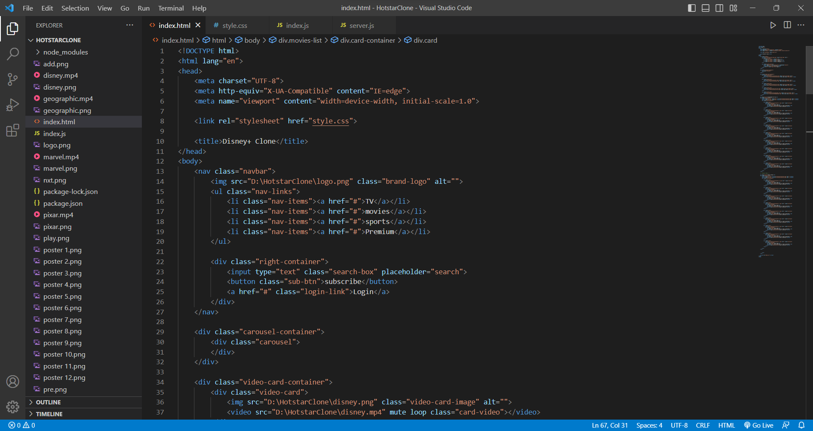

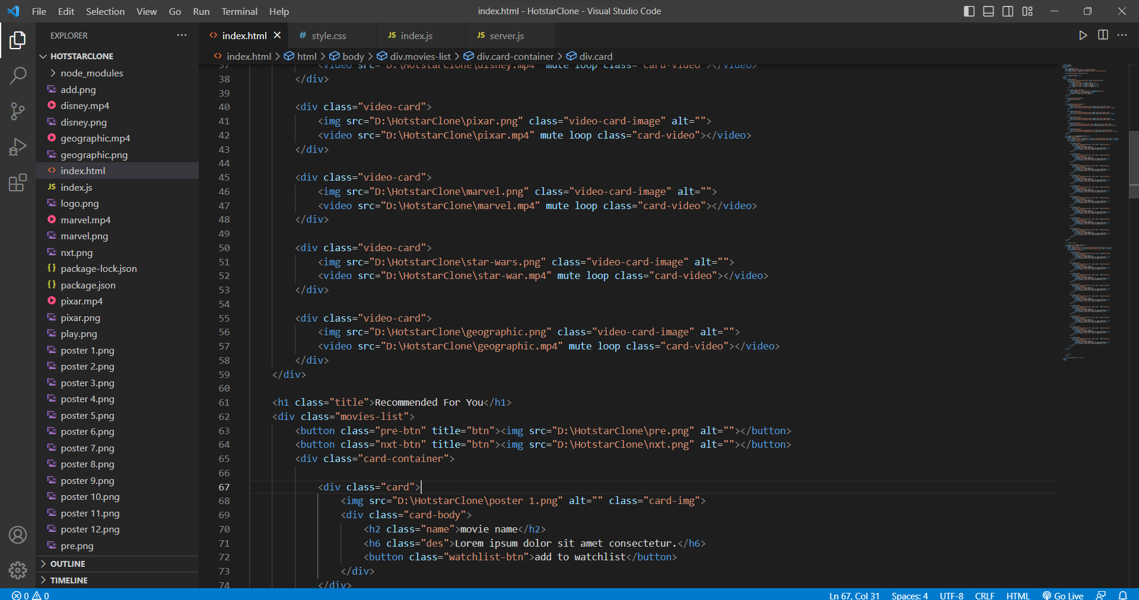

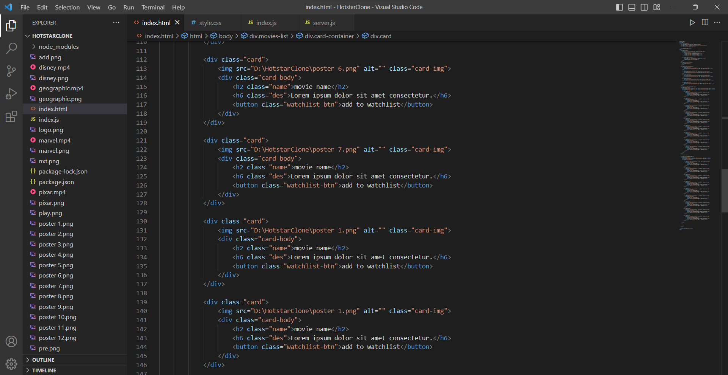

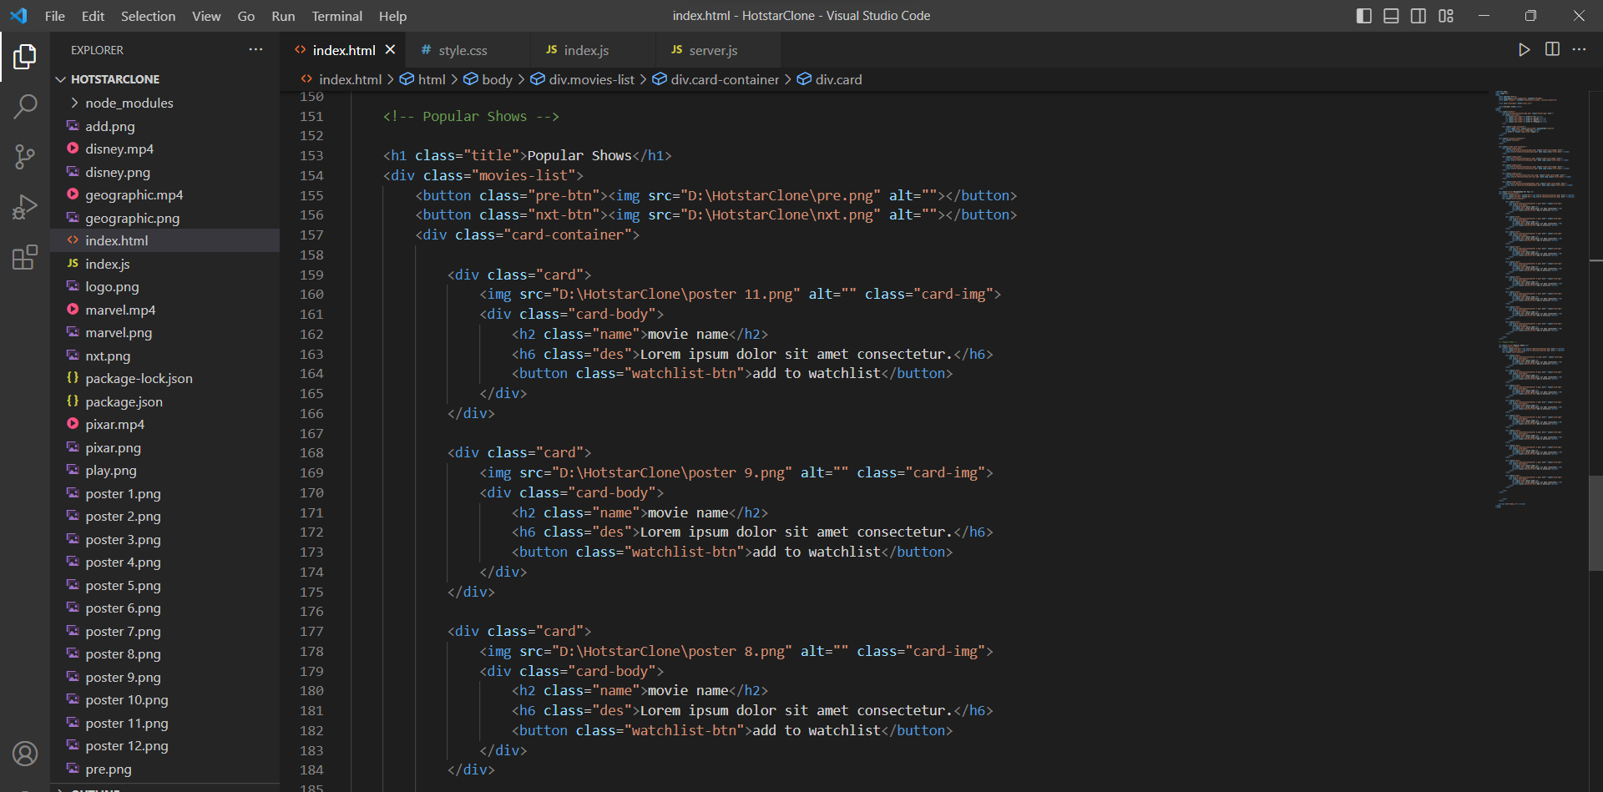



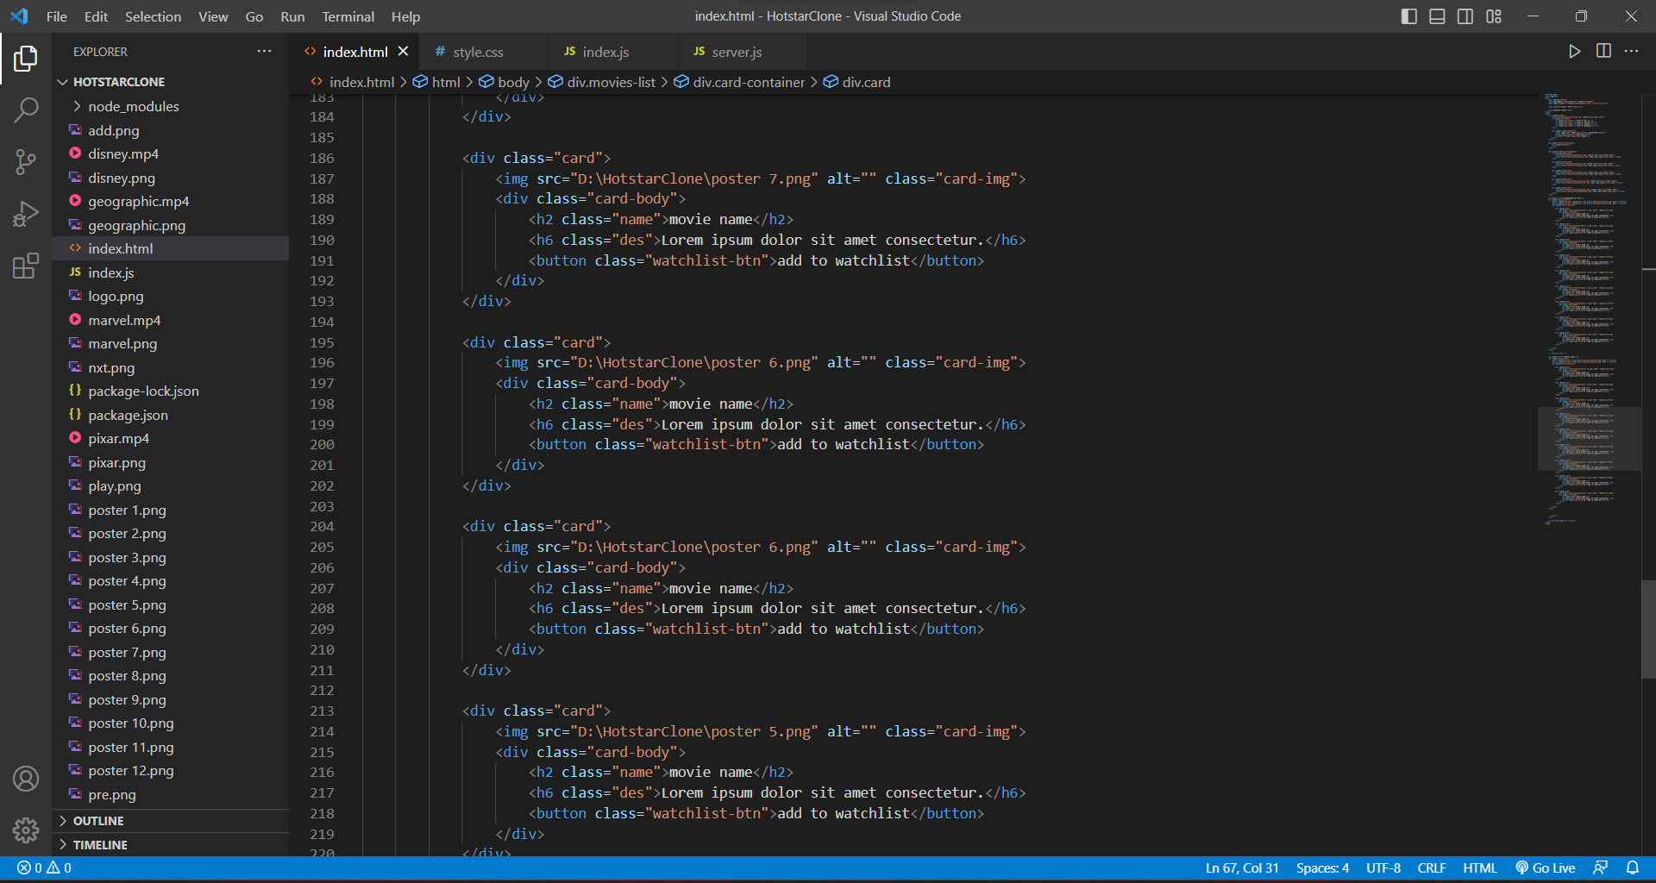

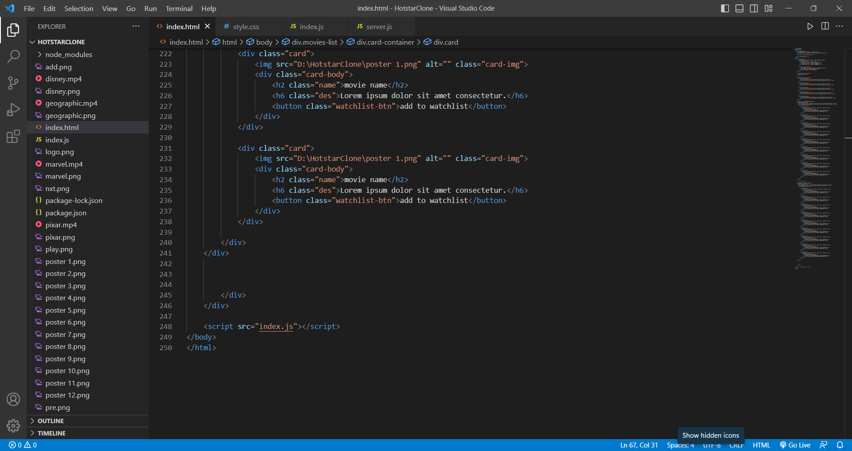

***CSS***

This is a CSS code that defines the styling for a web page.

The first block of code sets the default margin and padding for all elements and ensures that the box model is set to border-box. The next block of code sets the styling for the entire body of the page, including the font family, background color, and position.

The navbar section defines the styling for the header, including its fixed position at the top of the page, the background color, and its flexbox display.

The right-container section sets the styling for the right side of the navbar, which includes the search box, submit button, and login link.

The carousel-container and slider sections set the styling for the carousel slider section, including the dimensions, background color, and transition effects for the slide content.

The video-card-container and video-card sections define the styling for the video cards, including their dimensions, border radius, and transition effects.

The title, movies-list, and card-container sections set the styling for the movies list section, including the font size, background color, and dimensions.

Finally, the card section sets the styling for each individual card in the movie list section, including its border radius, dimensions, and transition effects.

***CODE***

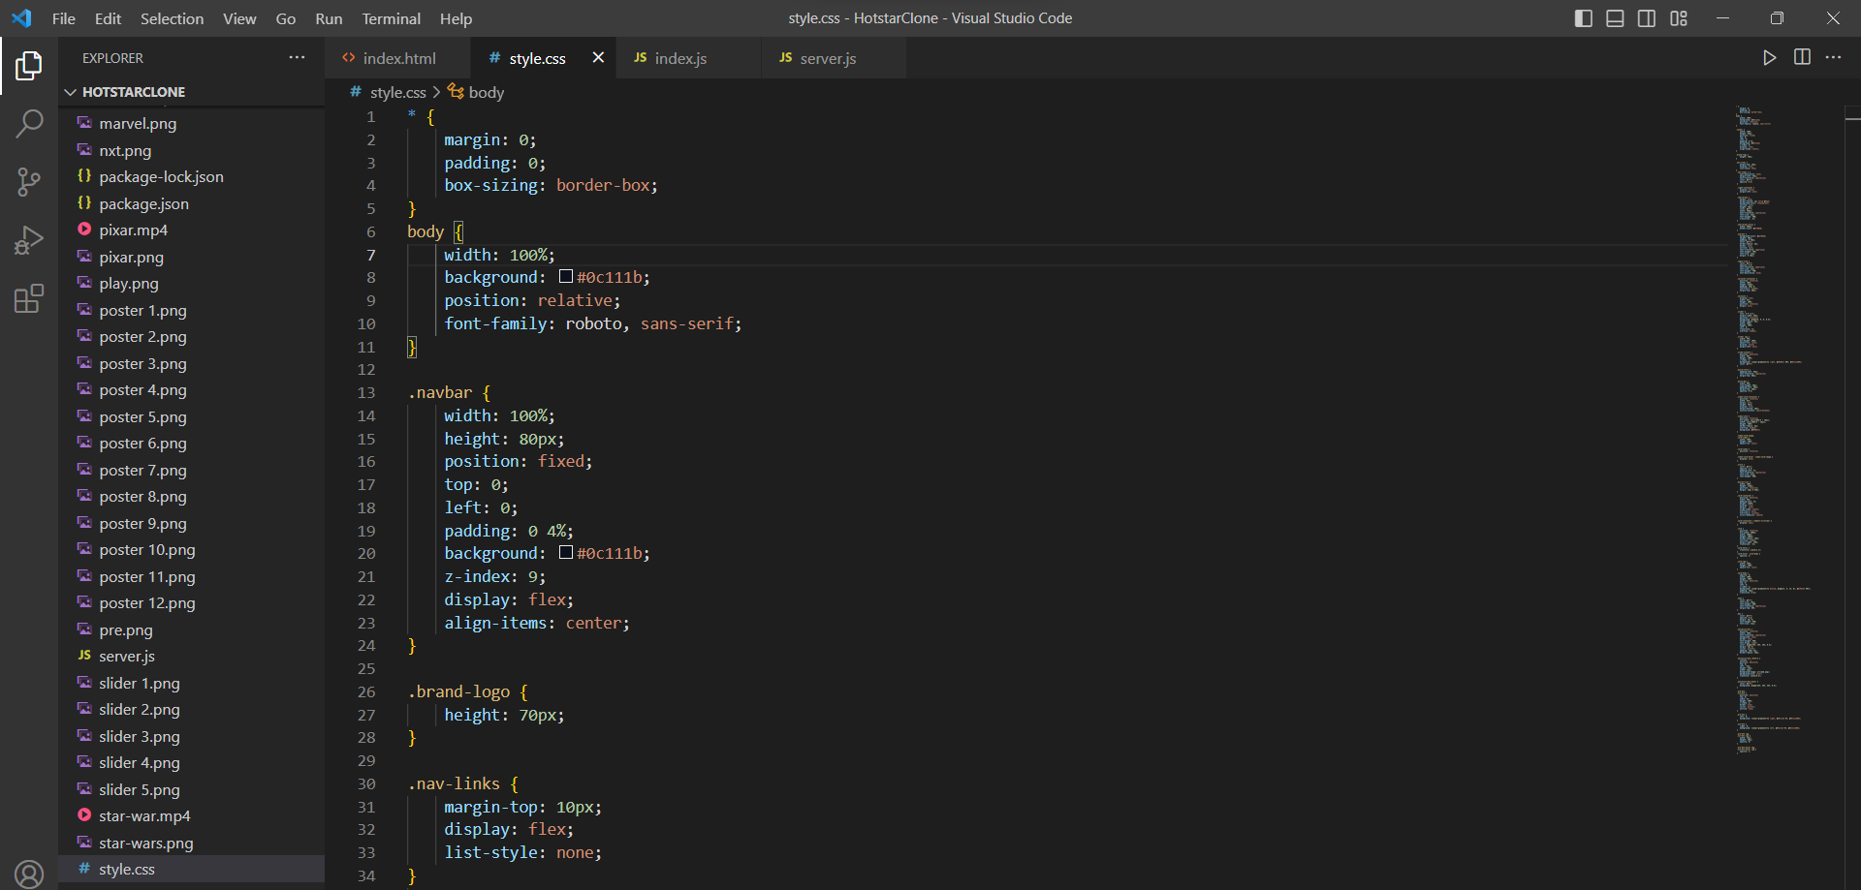

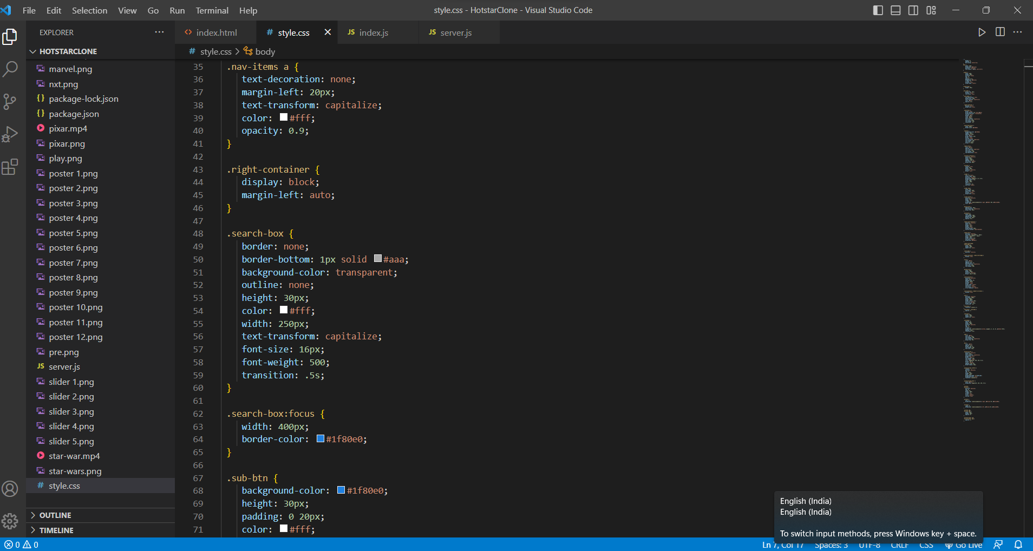

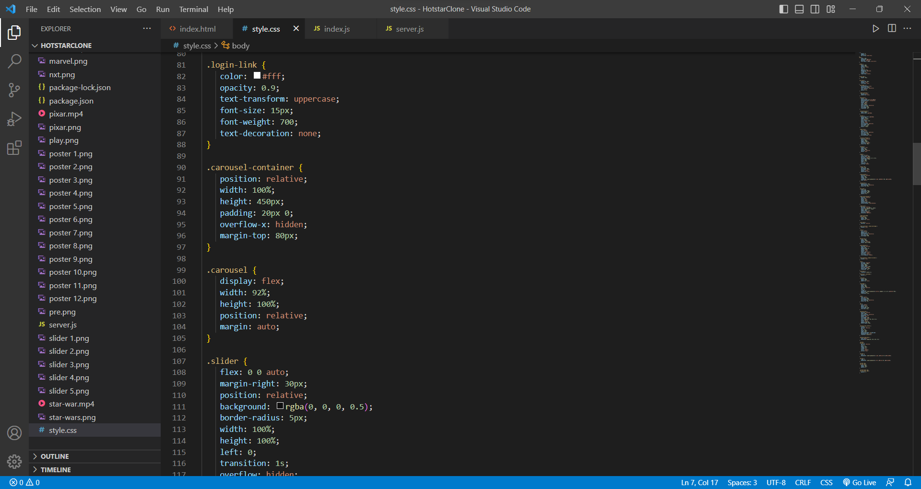

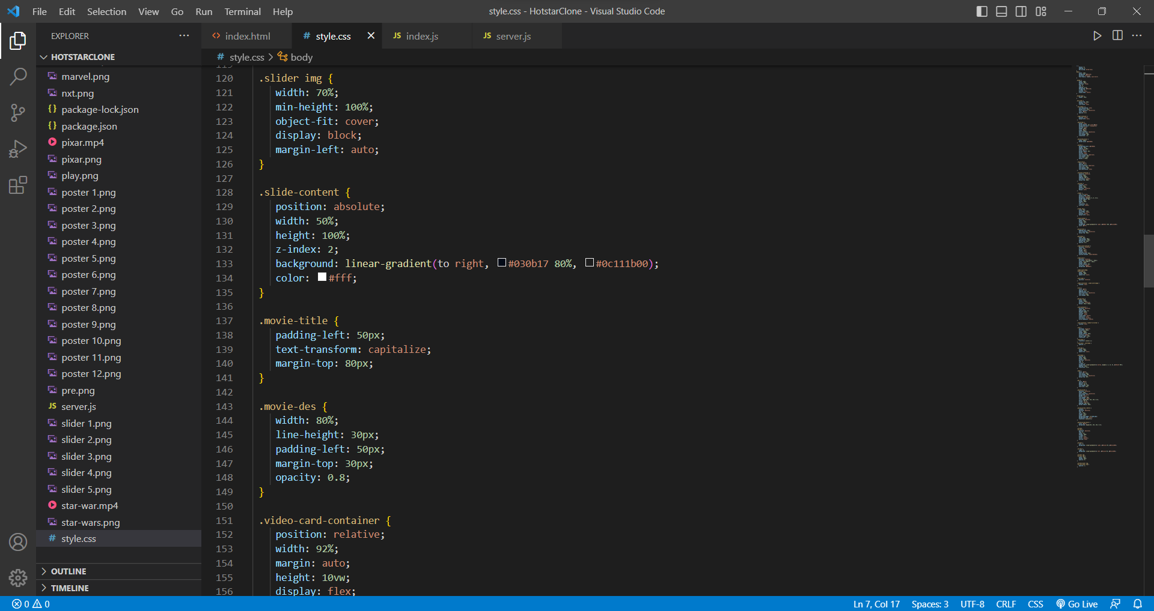

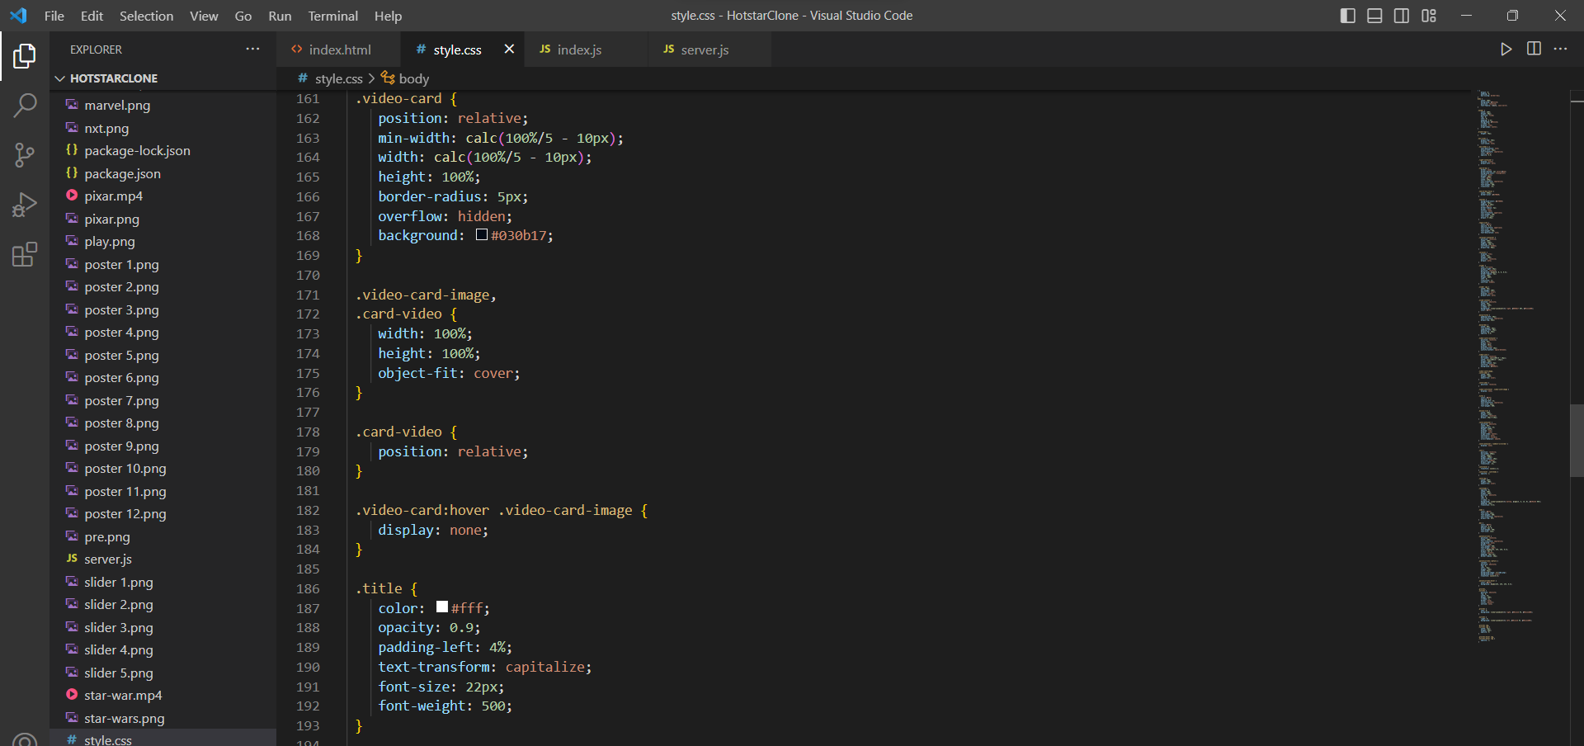

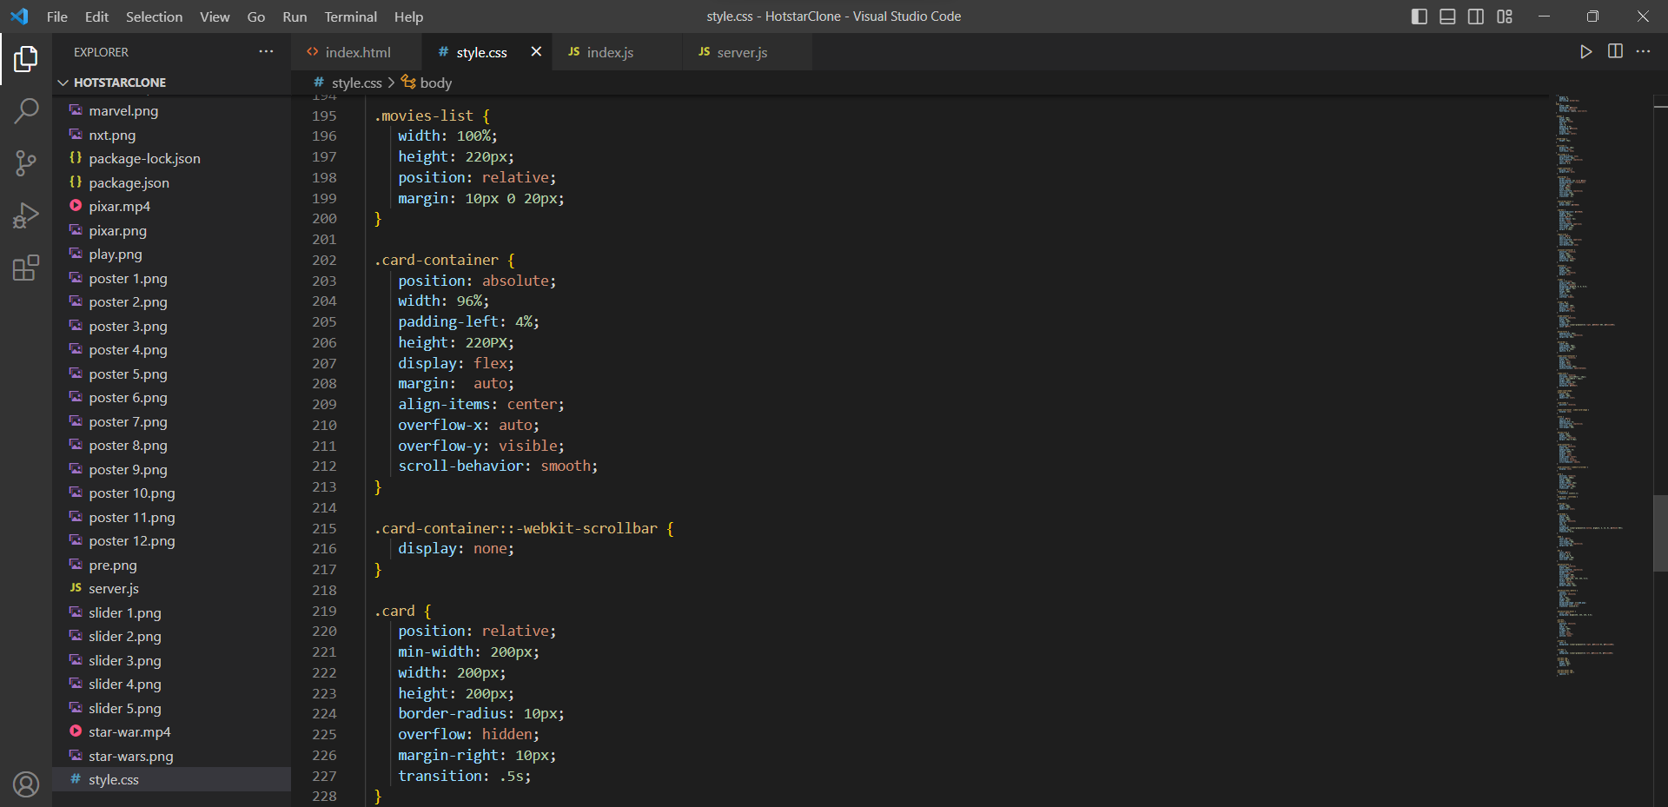

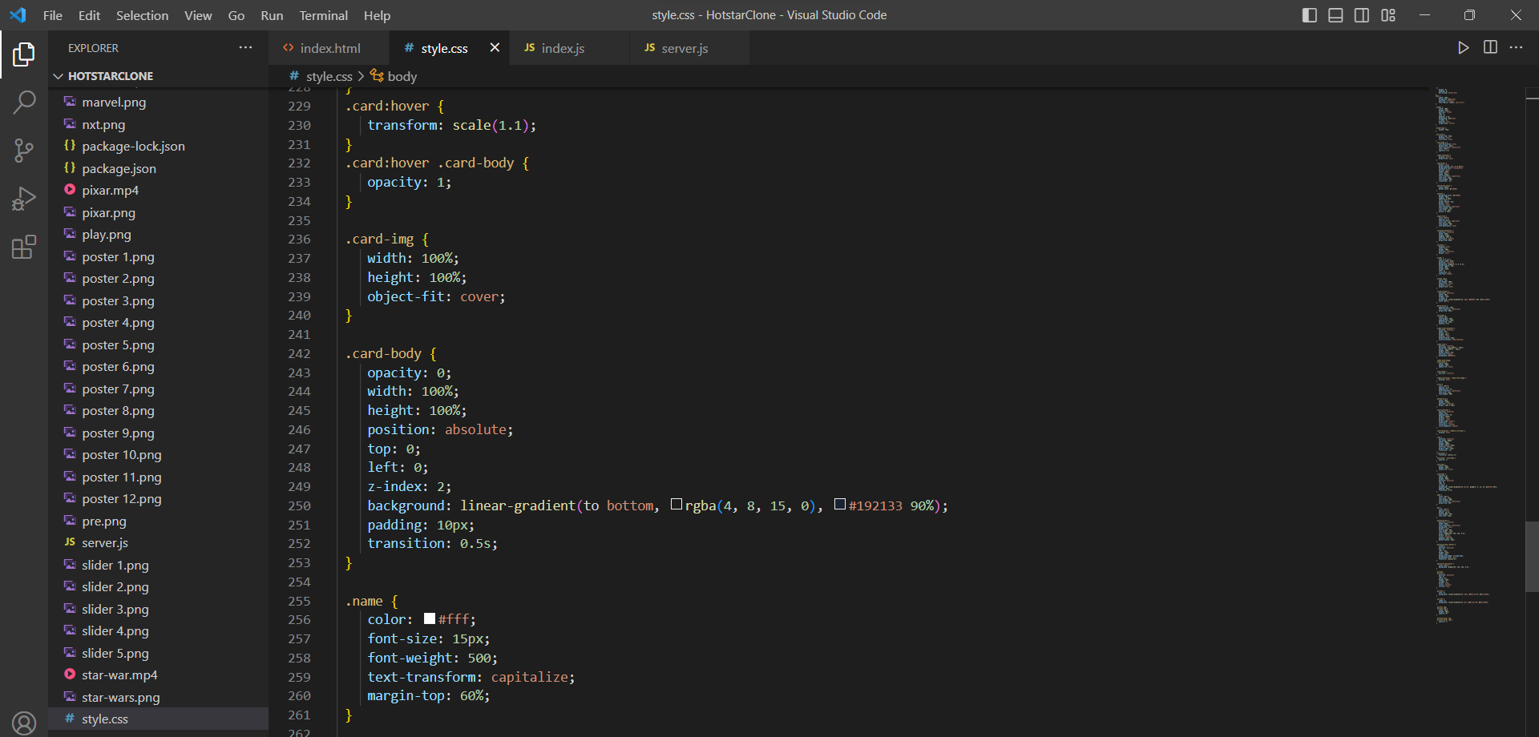

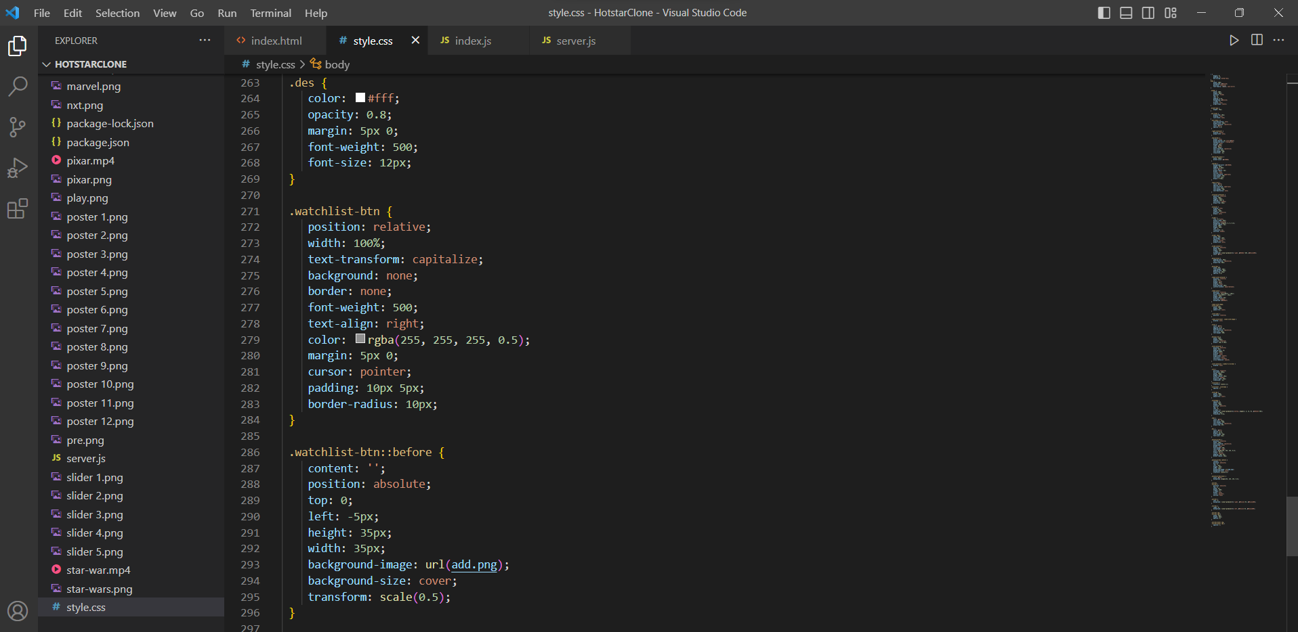

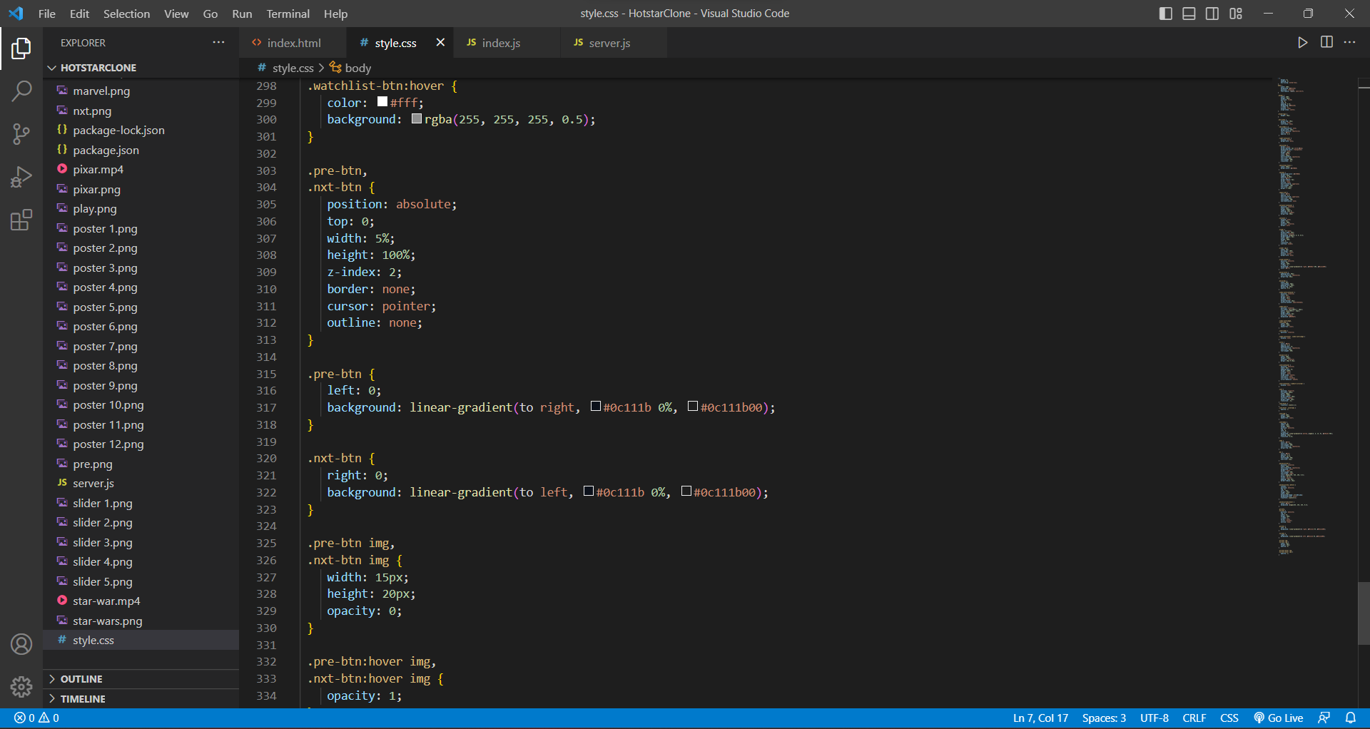

***JAVASCRIPT***

This is a JavaScript code that creates a carousel of movie posters and descriptions, as well as some video cards and card sliders.

The movies variable is an array of objects containing information about each movie, such as the name, description, and image.

The carousel variable is used to select the HTML element that will hold the movie posters and descriptions.

The createSlide function creates a new slide by creating HTML elements using the document.createElement method, setting the content of these elements, and attaching them to each other using the appendChild method. It then sets the src attribute of the image element to the URL of the current movie's image and adds class names to each element. The slide is then appended to the carousel and pushed to the sliders array.

The for-loop calls createSlide three times to create the first three slides, and the setInterval function calls createSlide every three seconds to continuously create new slides.

The code then selects all the video-card elements using document.querySelectorAll, and adds event listeners to each one that play and pause the video when the mouse is hovered over and leaves the element, respectively.

Finally, the code selects all the card-container, pre-btn, and nxt-btn elements using document.querySelectorAll, and adds event listeners to the previous and next buttons that scroll the card container left and right when clicked, respectively.

***CODE***

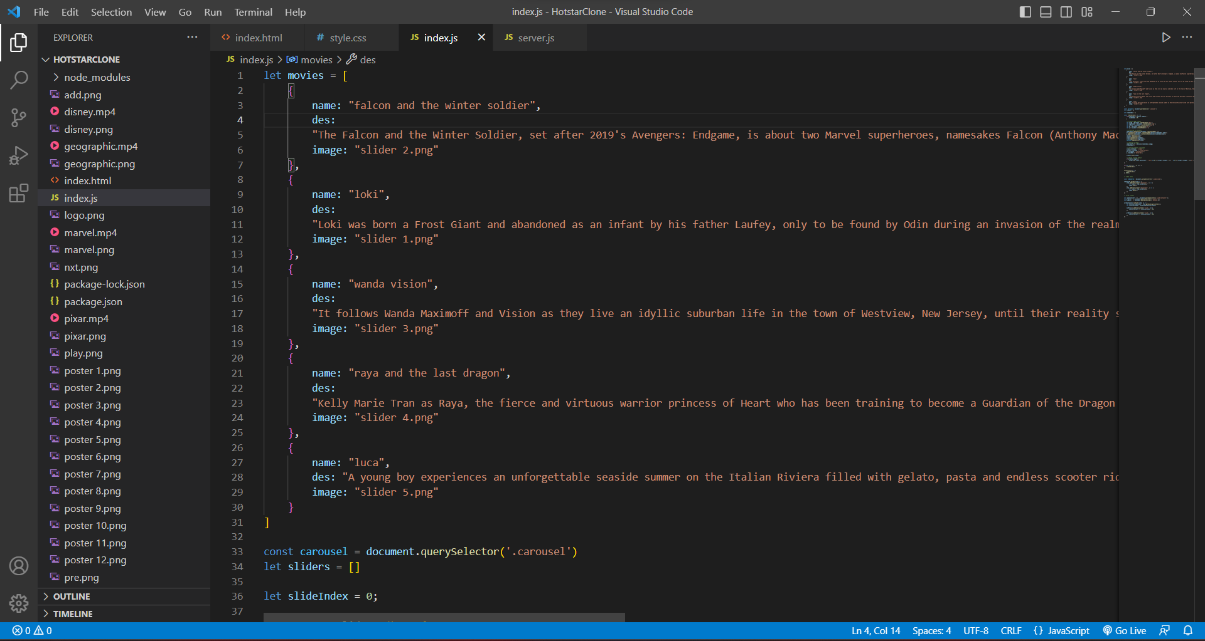

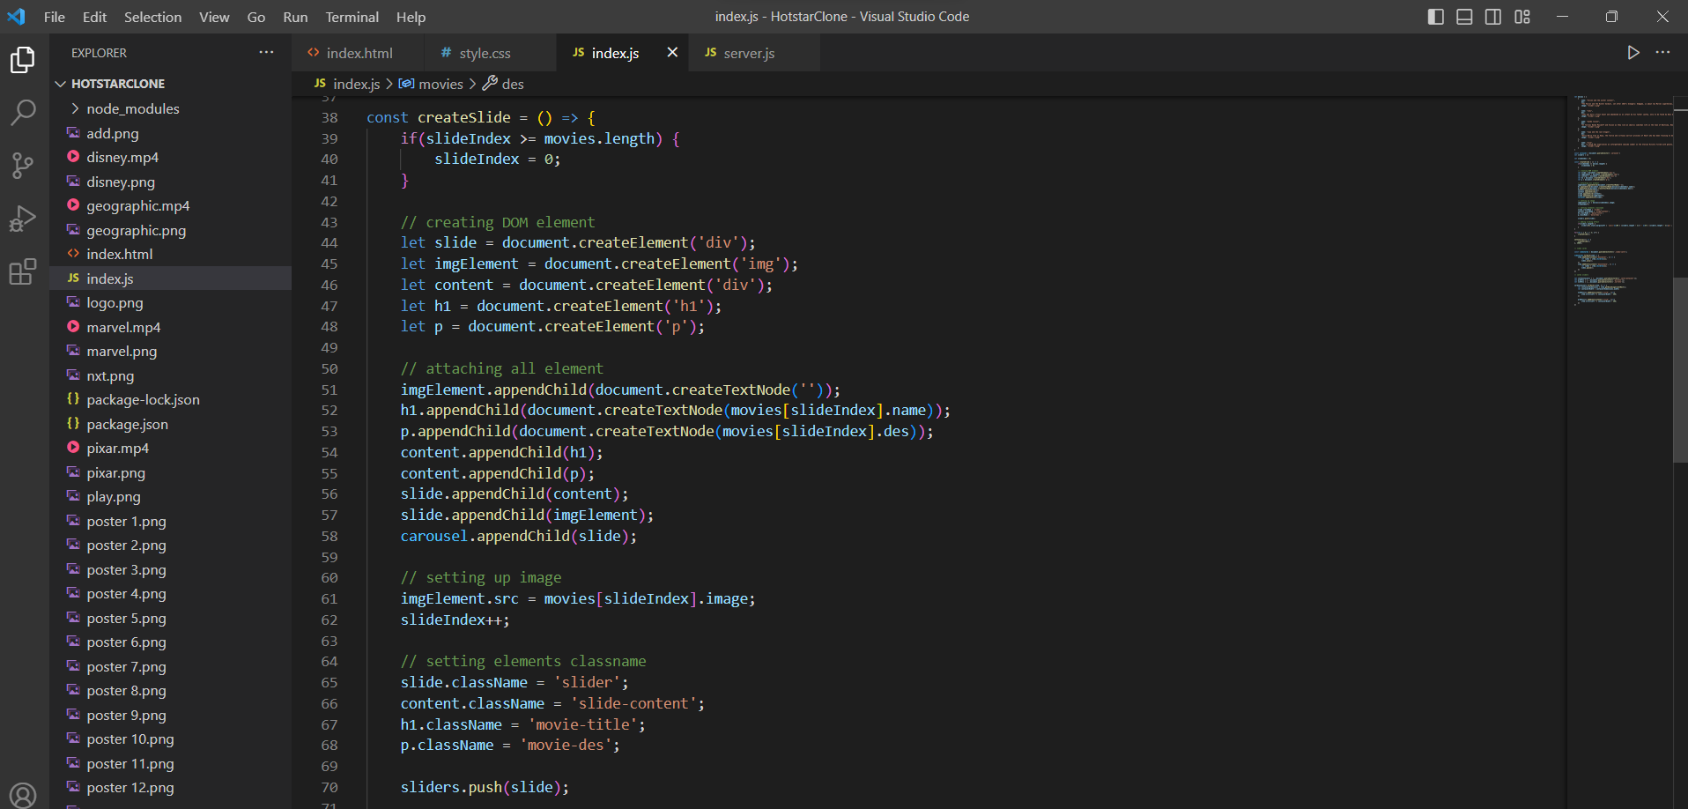

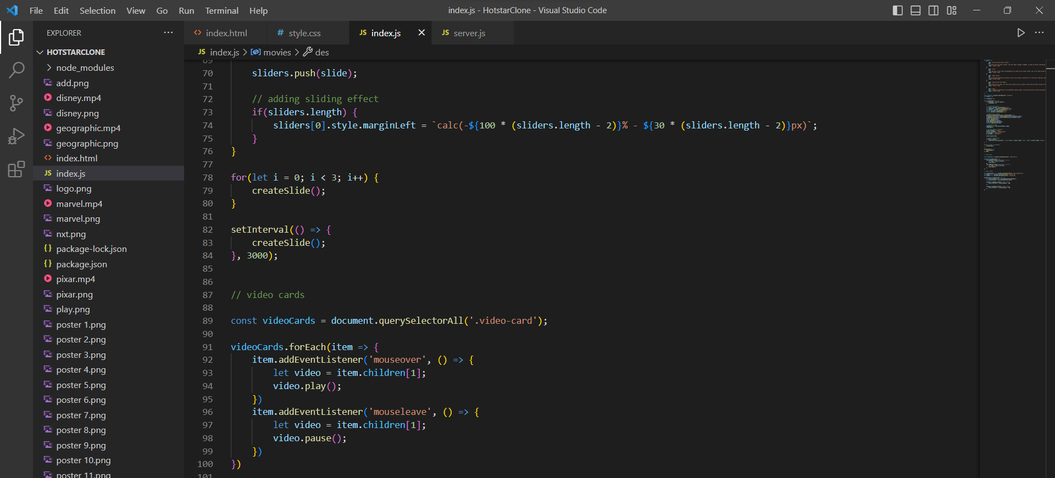

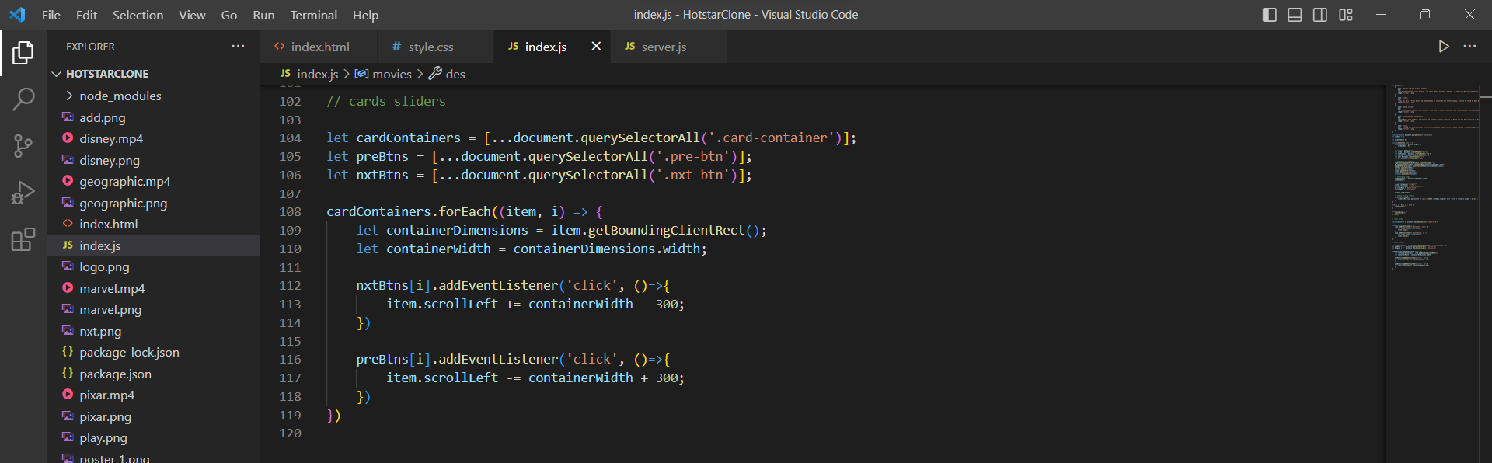

***OUTPUT***

